88 Radar speed sign install instruction

1.Product picture：
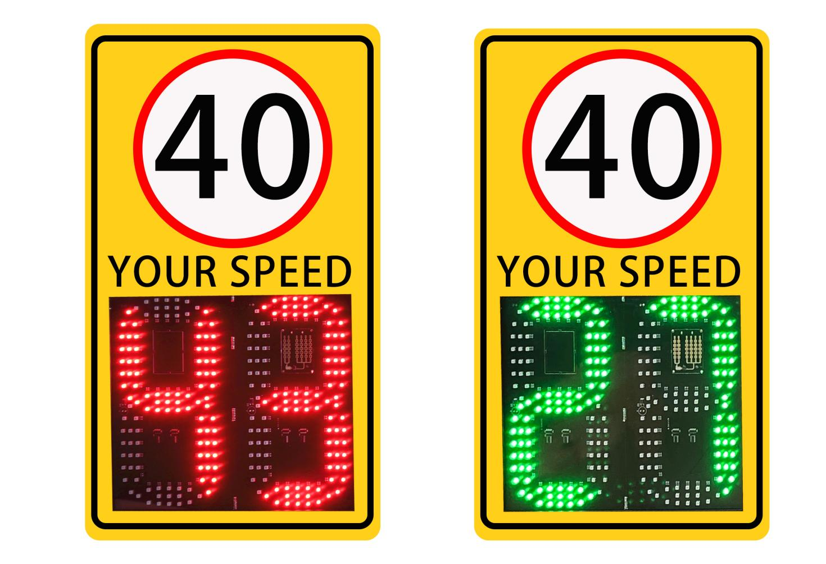
2.Product introduction：
In order to improve the driver's safety awareness of driving the vehicle, so that driving is not over speeding, the curve slows down, and at the same time, the vehicle in the opposite lane can be reminded to pay attention to the oncoming lane while driving into the curve.

Working Principle:Using millimeter wave radar as the source of detection(emitting electromagnetic waves), when the radar detect a moving vehicle passing, it will send a signal to the control board, the control board after precise operation, displayed the current vehicle’s speed. If don’t exceed the set speed with green display the vehicle’s speed. When exceed the set speed with red display the vehicle’s speed. It can remind the vehicle over speed and should slow down.

3.Working Parameter：
Display screen： | 88 LED screen
Working voltage： | AC110-220VAC / DC12/24V / solar powered
Modulation mode： | CW detection of moving vehicles，detection distance≥150 meters
Measuring range： | 1KM/H~250KM/H
Speed measurement error： | <±1KM/H
Parameter settings： | Phone APP
Multi-device linkage： | 433 wireless communication
Waterproof： | IP54
Working temperature: | -40-60℃
Install method: | Hoop install
Overspeed record | Need work with LPR camera
Weight: | 20KG
- product size
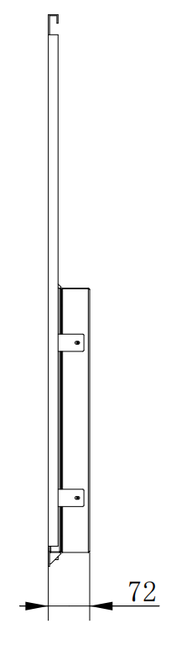
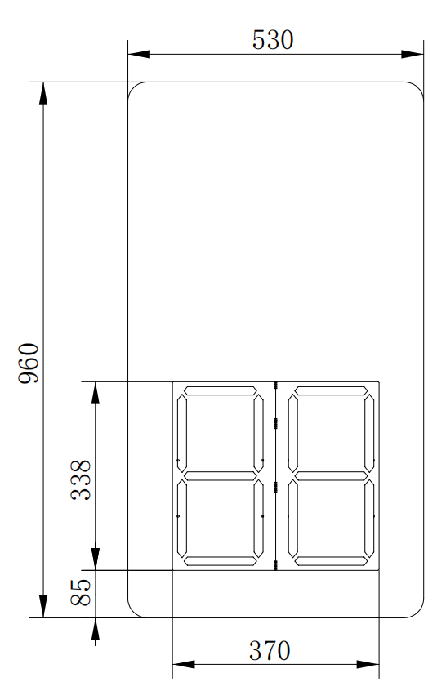

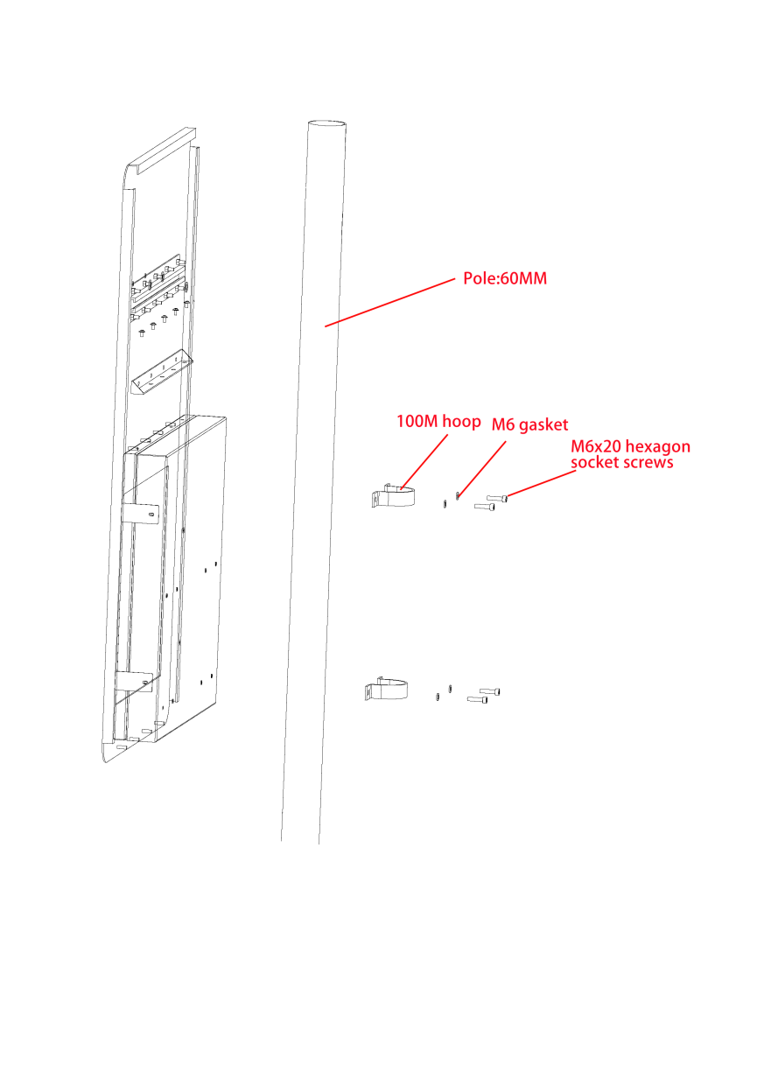
- Installation diagram
- 如图1所示，用M6垫片，M6*20内六角螺丝固定100M的抱箍在60MM直径的灯杆上.  - 用M8垫片，M8*90内六角螺丝固定100M的抱箍在60MM直径的灯杆上.  - 如图3所示，把固定在太阳固定板上的螺杆取出，把支架和太阳能固定板固定紧。  4、如图4所示用M8垫片，M8*10螺杆固定在杆子上。杆子需要打20MM直径的孔位。 | 图1  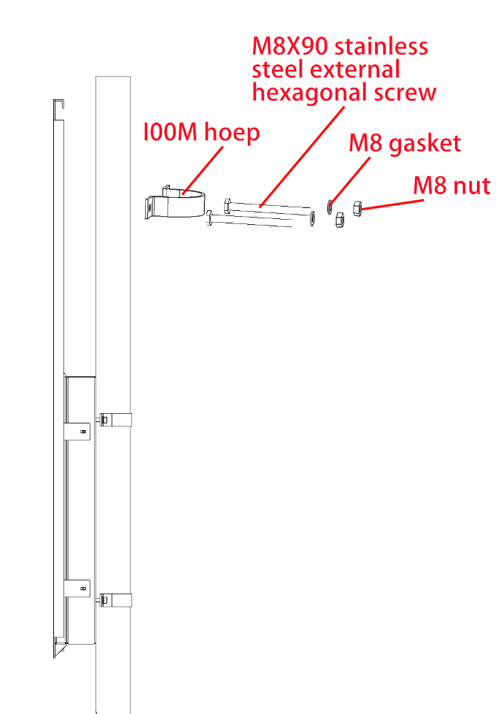  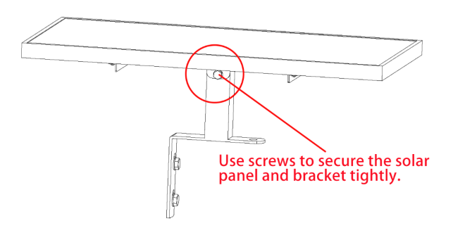  图2  图3  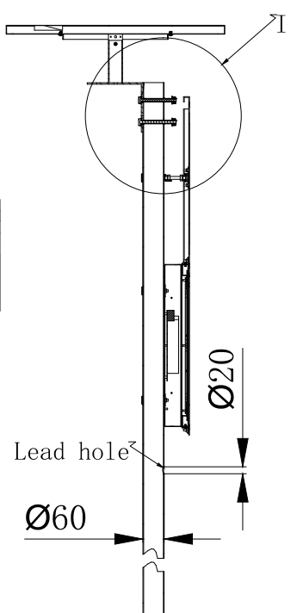  图4
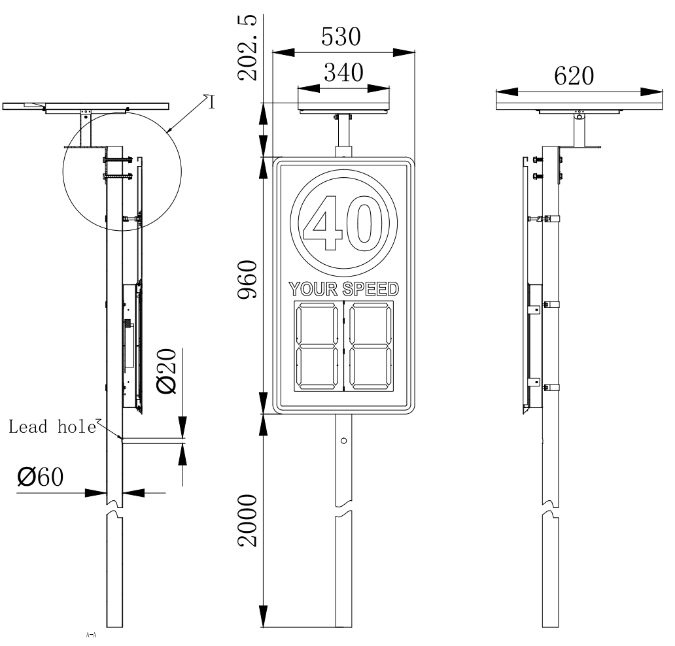
安装好效果如下图所示：

- wiring diagram
